Question 1:

ERD diagram:

A customer may place many orders and an order may have many items and one item may appear on many orders

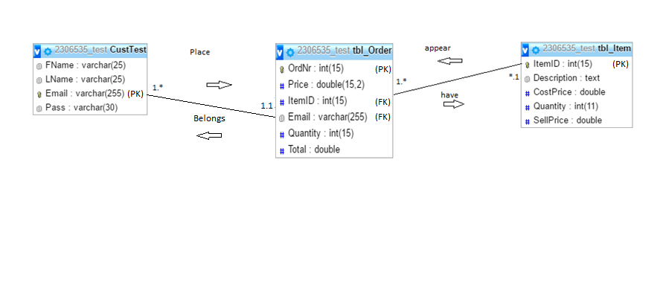

Question 2 :

1. Export done is in folder with name – export db structures
2. Text files created, 30 entries on users, was asked for only 15 item entries
3. Databases has been populated with txt file entries
4. Export included in table structure export name – export db structures
5. Script has been created and tested